**Assignment** : 13

**Title** : Create a workmail for your organisation.

**Amazon WorkMail :**

It is a secure, managed business email and calendar service with support for existing desktop and mobile email client applications. Amazon WorkMail gives users the ability to seamlessly access their email, contacts, and calendars using the client application of their choice, including Microsoft Outlook, native iOS and Android email applications.

**Steps to create an WorkMail for your organisation :**

1. Log in to the console and search for ***Amazon Workmail.***
2. Click on ***Amazon Workmail*** and then click on ***Create organisation.***

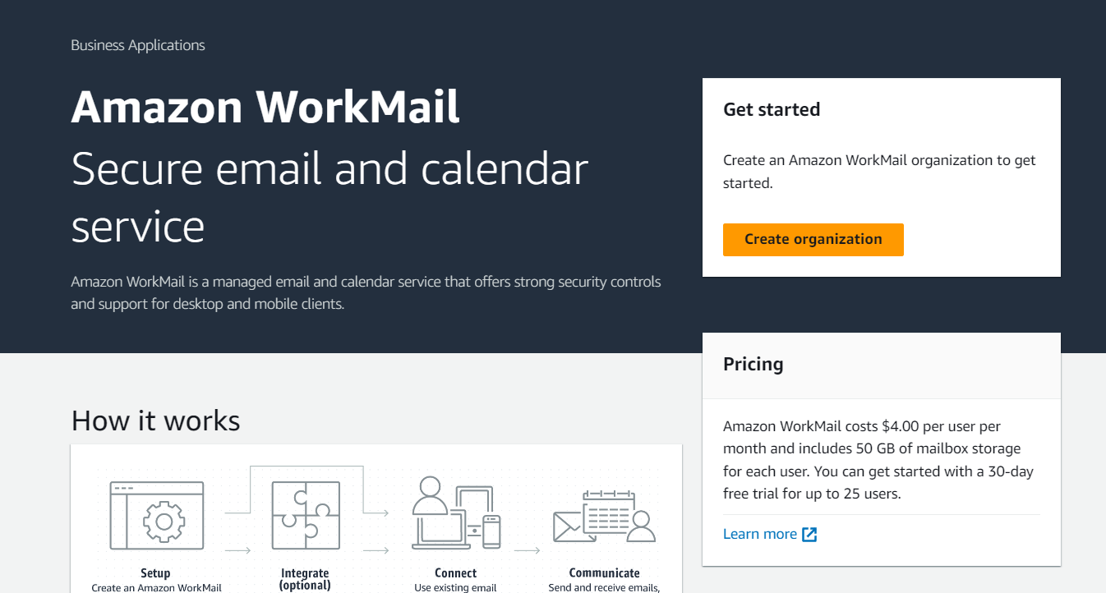

1. Create an Amazon WorkMail Organisation page opens.

Under ***email domain*** - Choose ***Free Test domain.***

Under ***Alias*** - write the alias name for your organisation (example : ***l-and-p***)

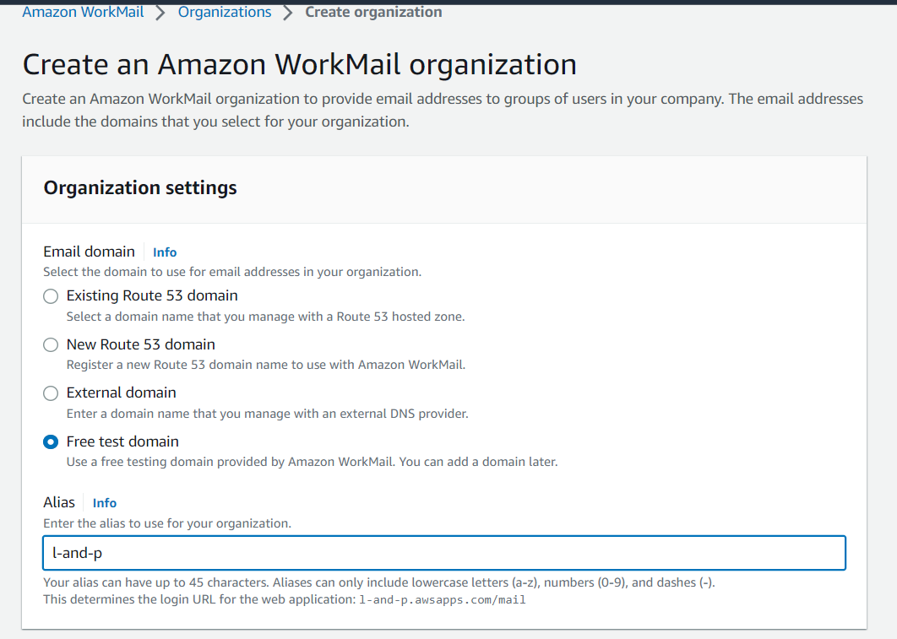 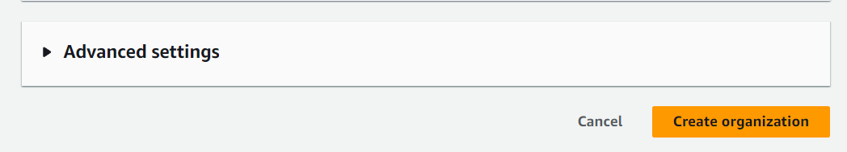

1. Click on ***Create Organisation*** . Your organisation is created and ready to use.
2. Now click on ***alias name*** of the created organisation ***(l-and-p)***

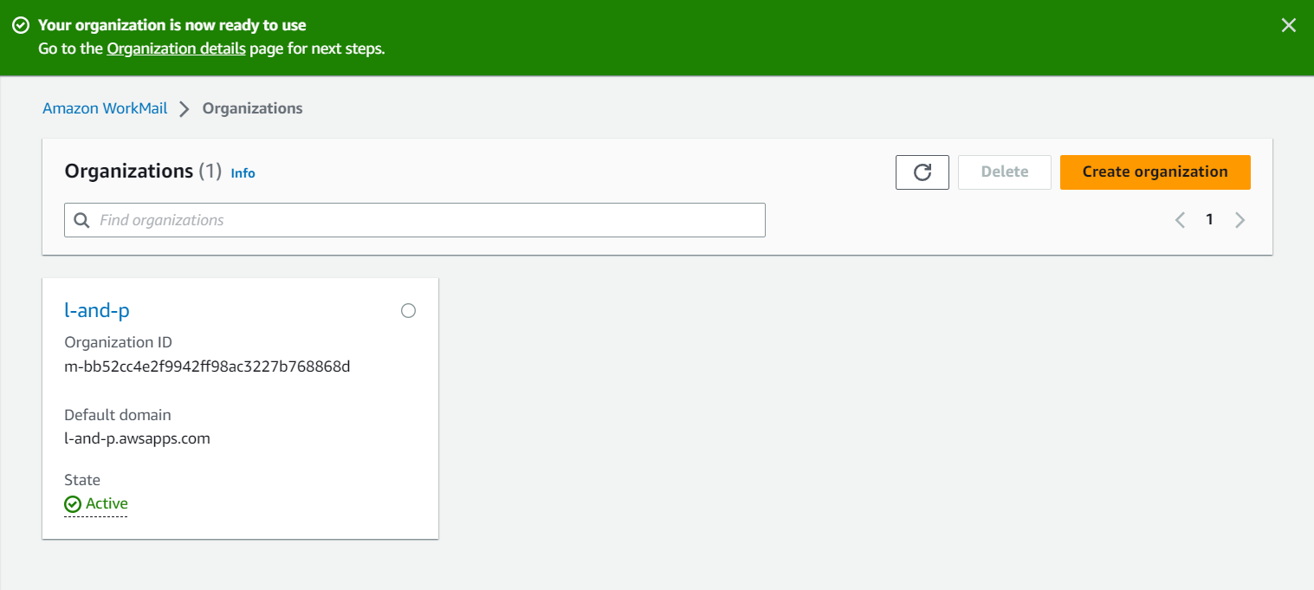

1. Select **Users** on the left hand side column , then click on ***Create User***.

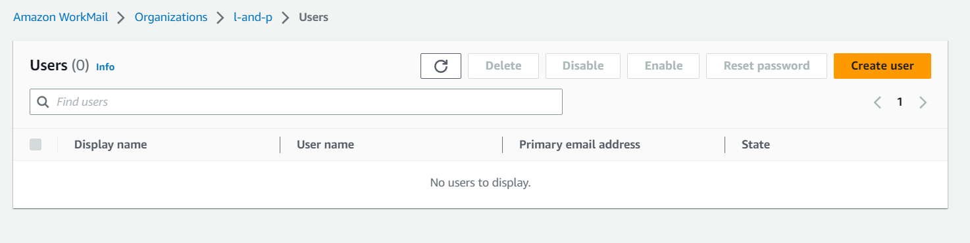

1. Create a User page opens

Under user details provide an username e.g s-n-e-h-a and the display name e.g. Sneha

You can also provide First name and last name.

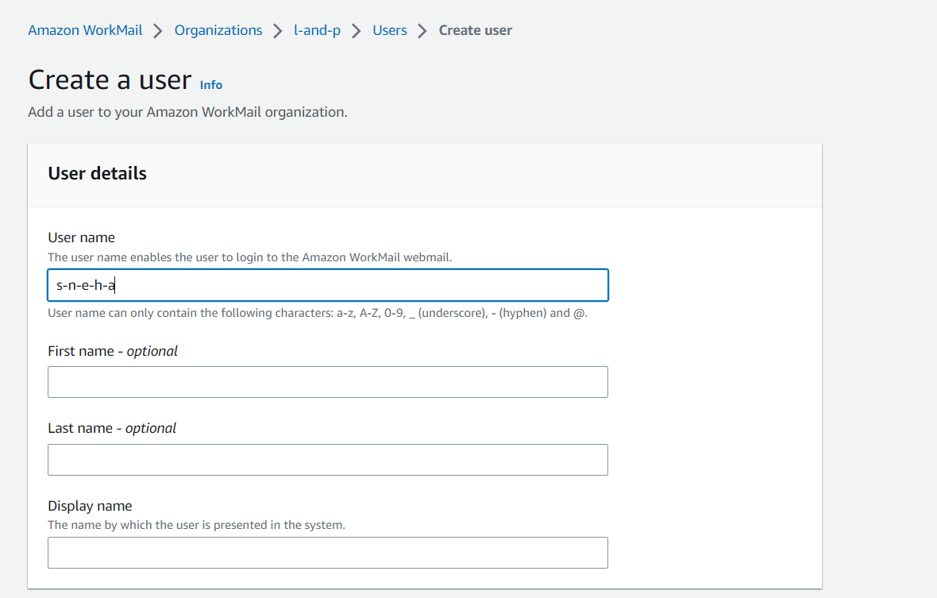

1. Now under the email setup , the email address will be generated as :

**<username> @ <organisation name>.awsapps.com**

Create a password , repeat and click on **Create User**

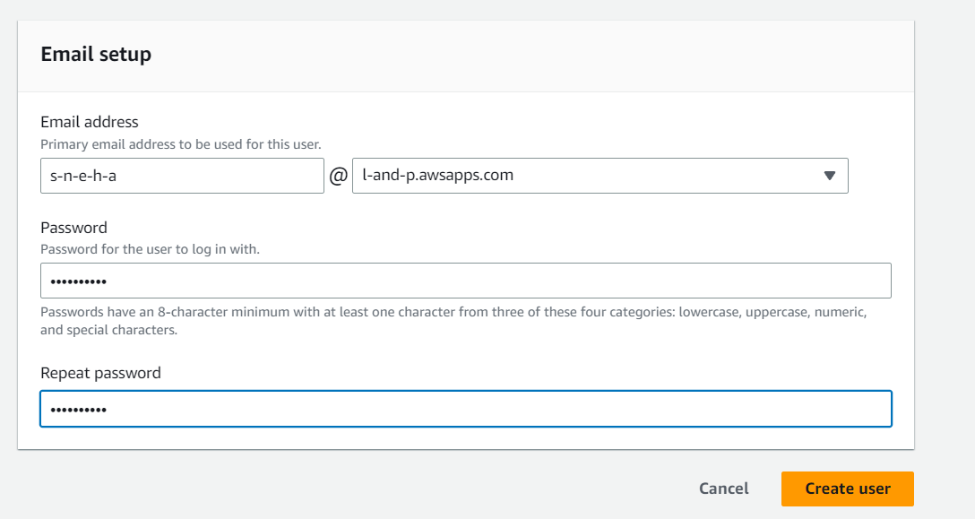

The user is created as shown below :

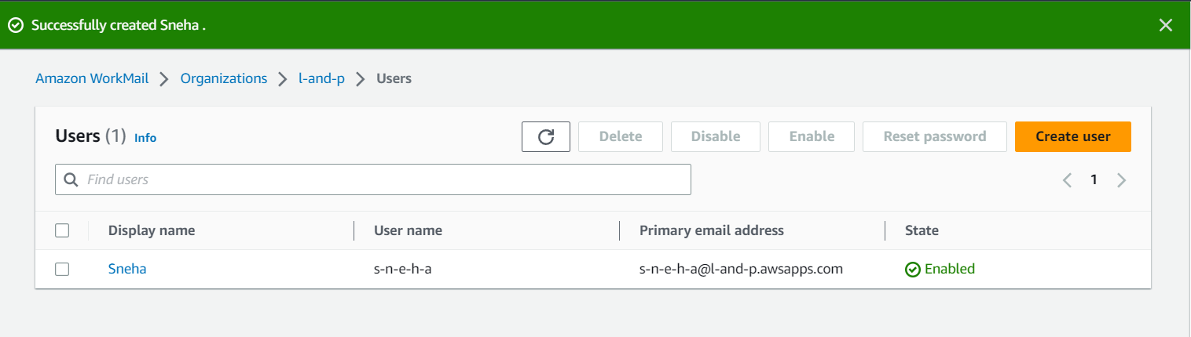

9. Go to the **organisation** and click on the link under **Amazon WorkMail web application** , the Amazon WorkMail log in page will open .

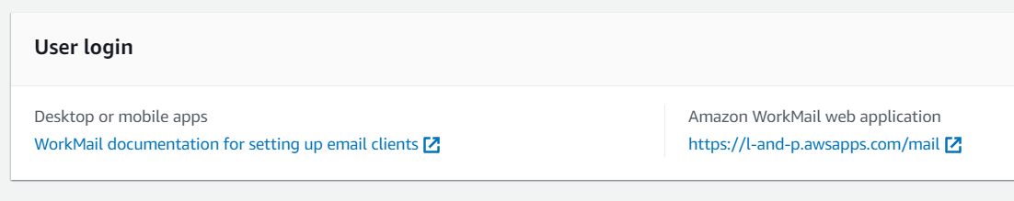

10. in Username provide the **username** you provided (e.g. s-n-e-h-a)

And the **password** you provided earlier

- Click on **Sign in .**

Once You are logged in the Amazon WorkMail page opens.

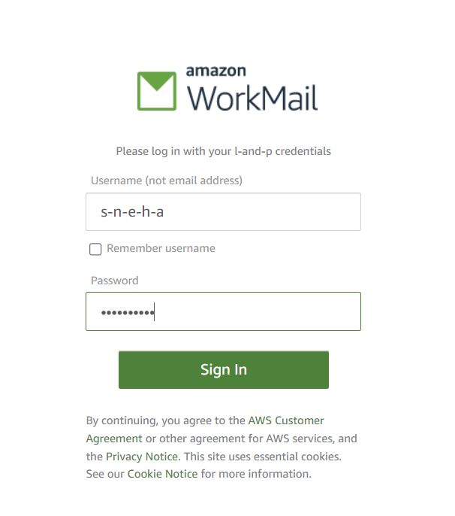 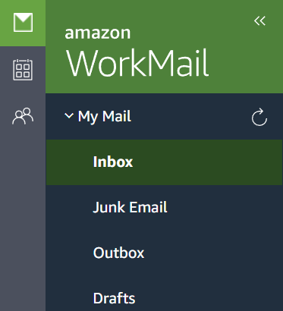

11. You can send email to any other email by following steps :

**New item->New Email->Add recipient email in To:->write the content->Send**

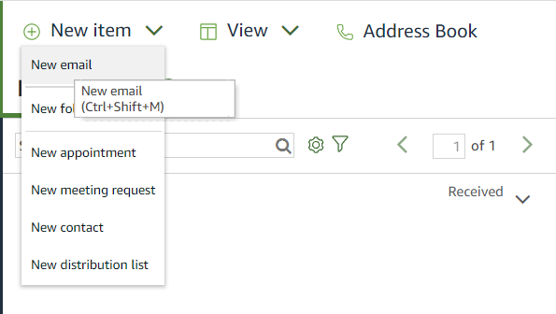 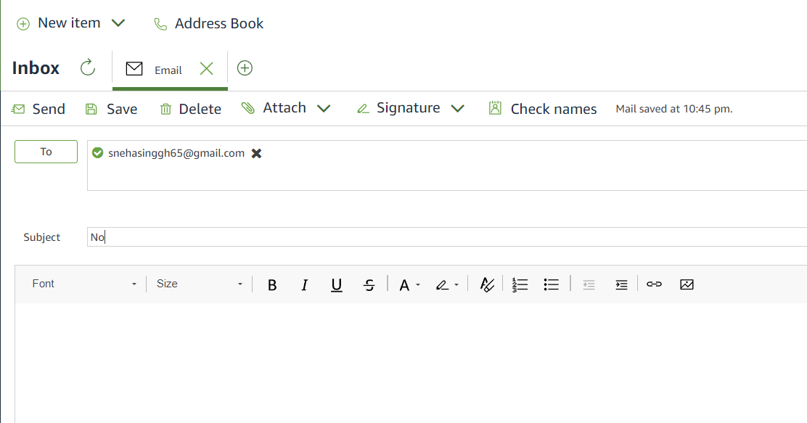

You can also receive messages in Inbox.

1. To delete the Workmail delete the user and then Delete the organisation you created.

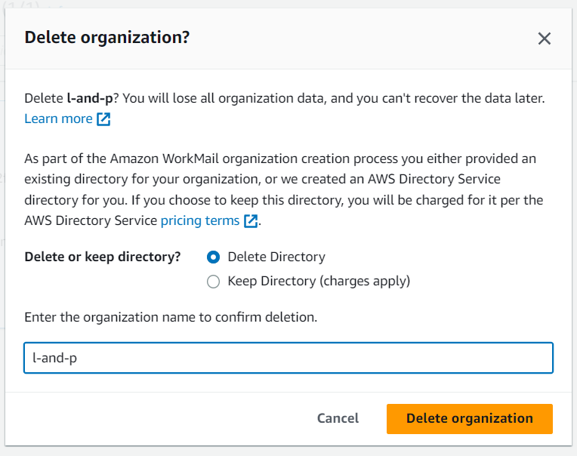

**Assignment** : 15

**Title** : Create Serverless Computing Service

**AWS Lambda :** It is a compute service that lets you run code without provisioning or managing servers.Lambda runs your code on a high-availability compute infrastructure and performs all of the administration of the compute resources, including server and operating system maintenance, capacity provisioning and automatic scaling, and logging. With Lambda, all you need to do is supply your code in one of the language runtimes that Lambda supports.You organize your code into Lambda functions. The Lambda service runs your function only when needed and scales automatically.

Steps to create a function:

1. Open the Lambda from the aws console

[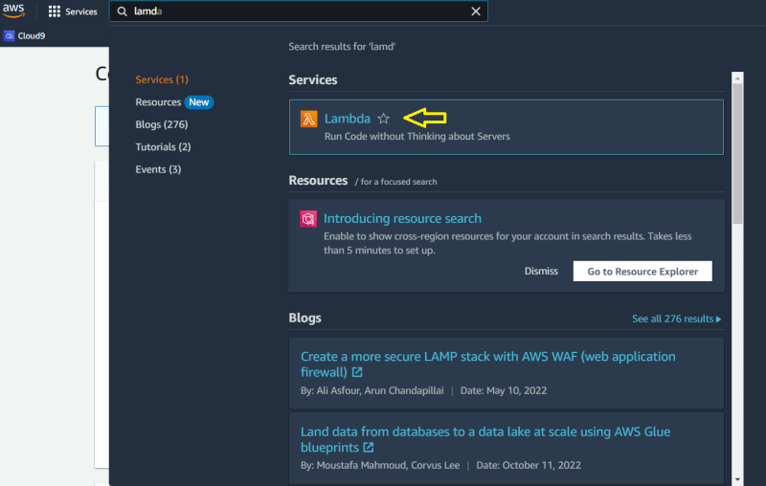](https://res.cloudinary.com/practicaldev/image/fetch/s--qRmtMNWP--/c_limit,f_auto,fl_progressive,q_auto,w_800/https:/dev-to-uploads.s3.amazonaws.com/uploads/articles/ty3qvospemwf2f2wc412.png)

1. Click ****Create Function**** button

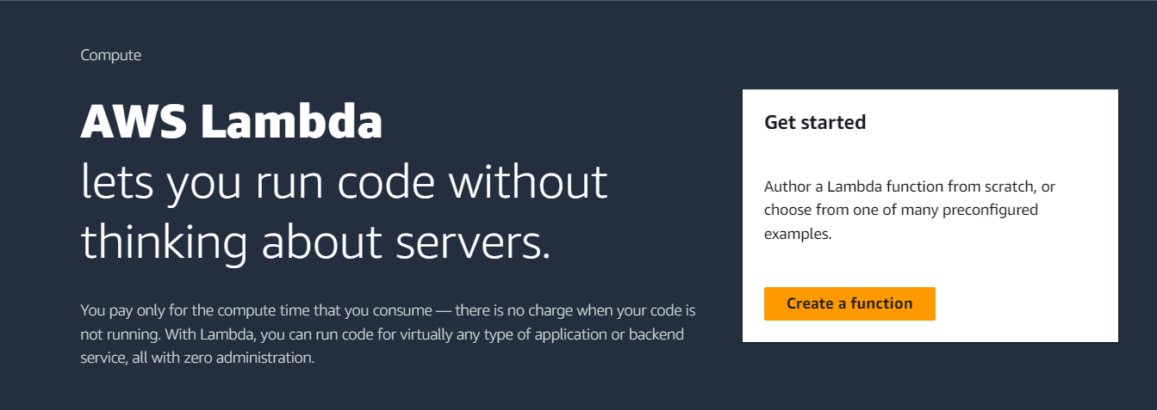

1. Choose ****Author from scratch option**** -Specify a Function name, I am going to create a function to print a Welcome message to the user.For example , my function name is going to be "func_x1"

4. Choose Node.js 18.x (default) as your runtime. For me its Python 3.9 now and I am selecting it . Scroll down and now leave the rest of the settings to the ****default selections****

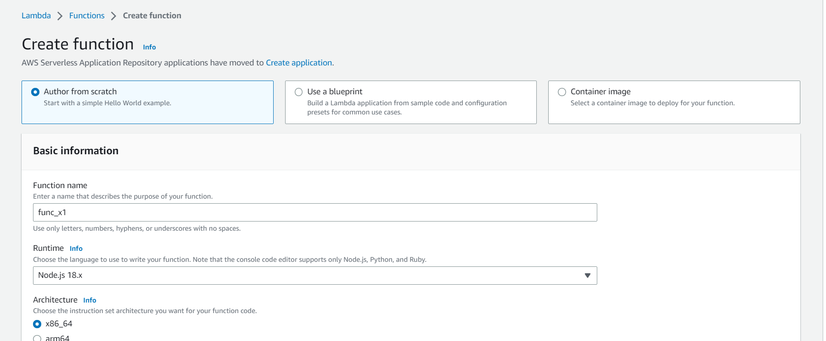

Click ****Create Function**** button

[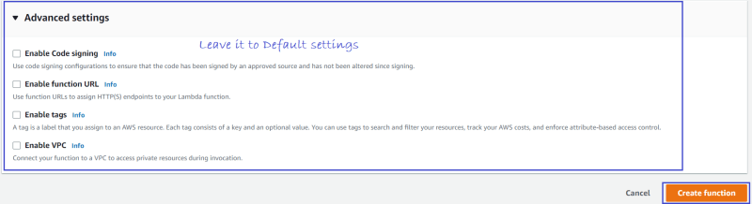](https://res.cloudinary.com/practicaldev/image/fetch/s--4Rl5PX87--/c_limit,f_auto,fl_progressive,q_auto,w_800/https:/dev-to-uploads.s3.amazonaws.com/uploads/articles/4jd5ehjoawlk3su0vnbe.png) Lets wait for couple of minutes to get navigated to the function page Now on the function dashboard, there are several tabs Code, Test, Monitor, Configuration, Aliases, and Versions

We are now on the Code tab, down here we can see a index.mjs file.

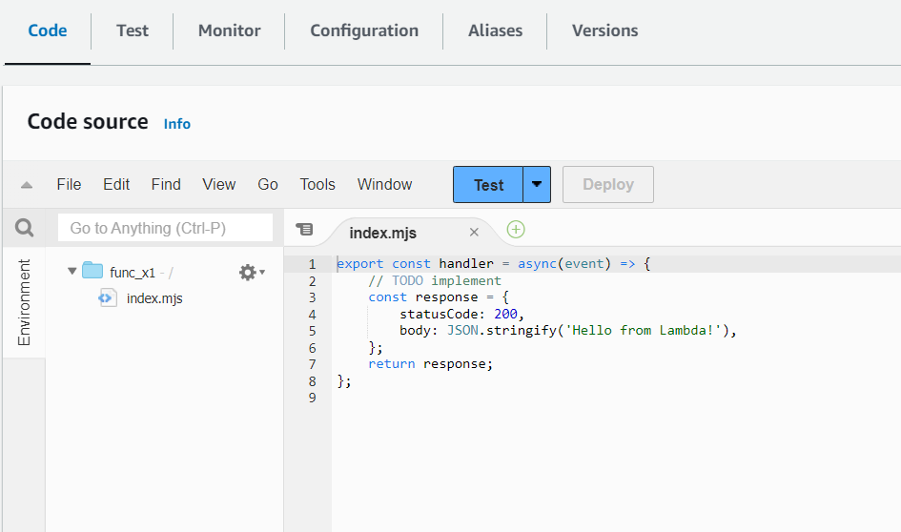

Edit the text part of the code like add “sneha” in place of “lambda” in the code on the file index.mjs then go to File and click on Save.

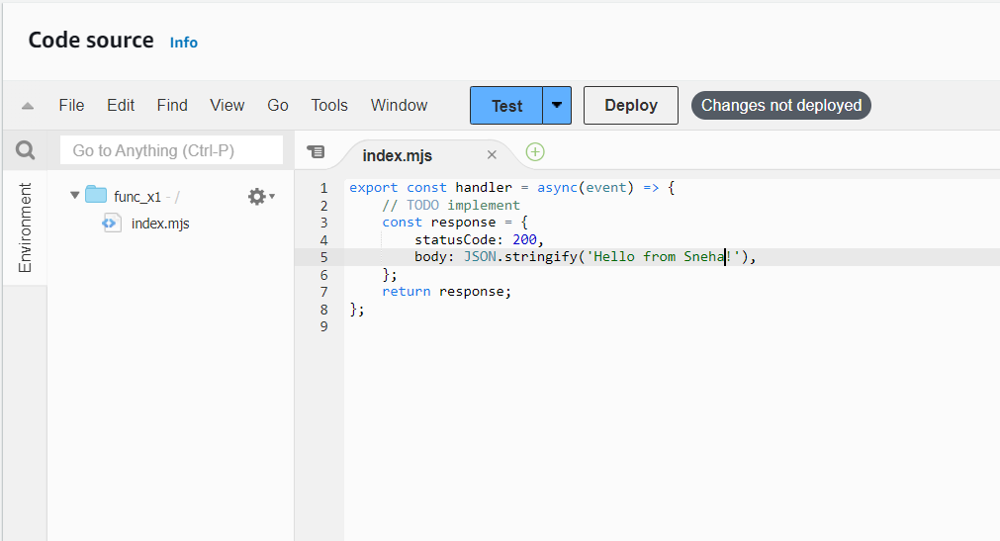 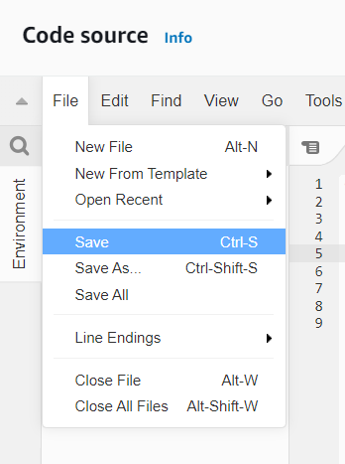

## Steps to Create a Test Event and execute the Lambda Function

****A test event is a JSON object that mocks the structure of requests emitted by AWS services to invoke a Lambda function****. Use it to see the function’s invocation result.

1. Click on Test.
2. Lets create a new test event .Specify the Event name like eve1
3. Click on Save

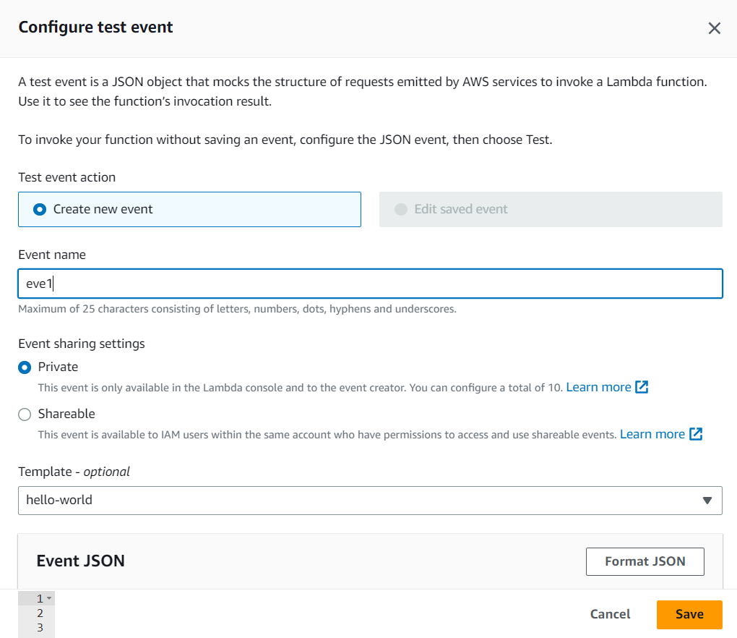

1. Now when you test you get the execution result as the original code.
2. To get the changed result , click on deploy then test.

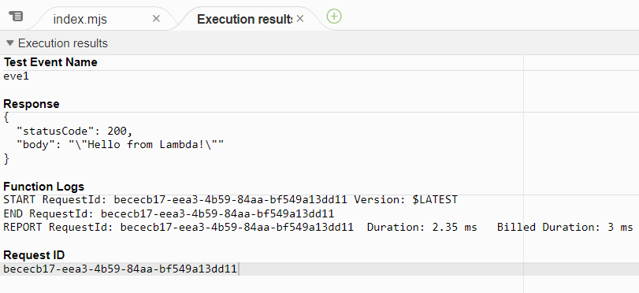 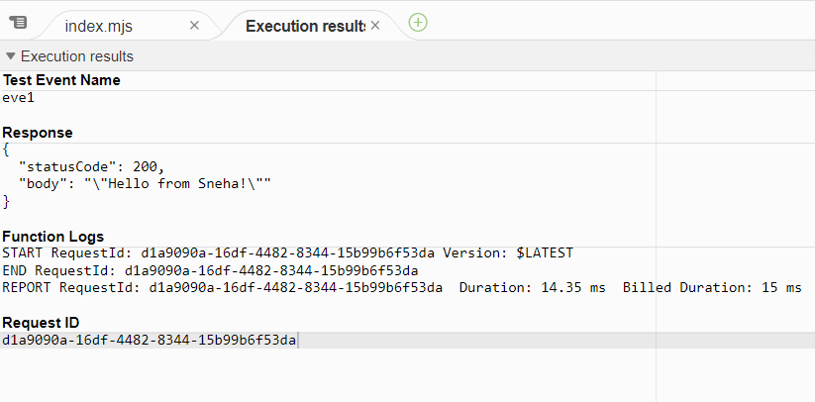

AFTER DEPLOY

BEFORE DEPLOY

1. Now go to Configuration - click on Function Url
2. Click on Create Function URL

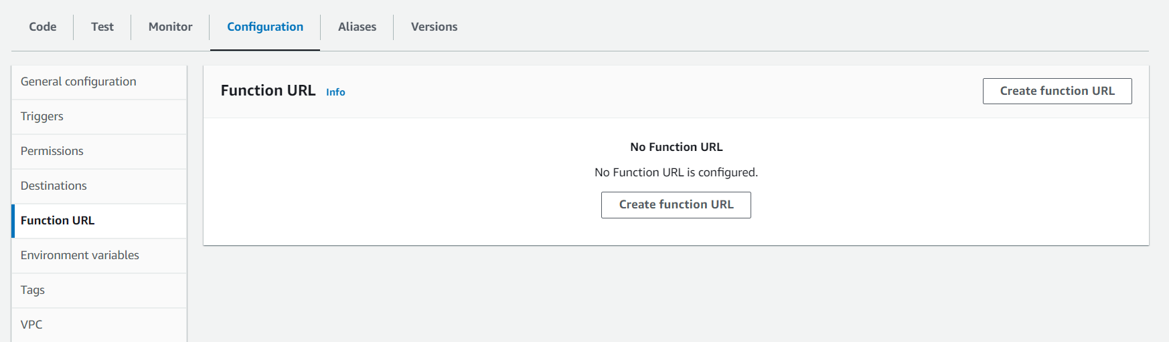

1. n configure Function URL , choose None under Auth type and click on Save.

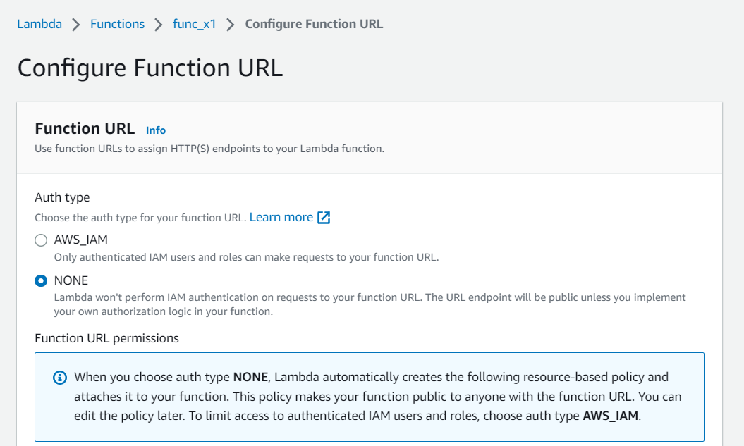

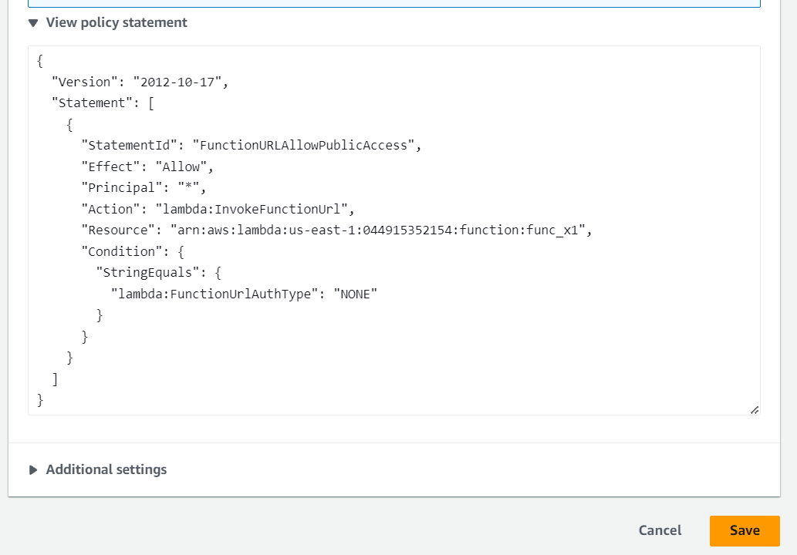

1. Function url is created , Click on it.

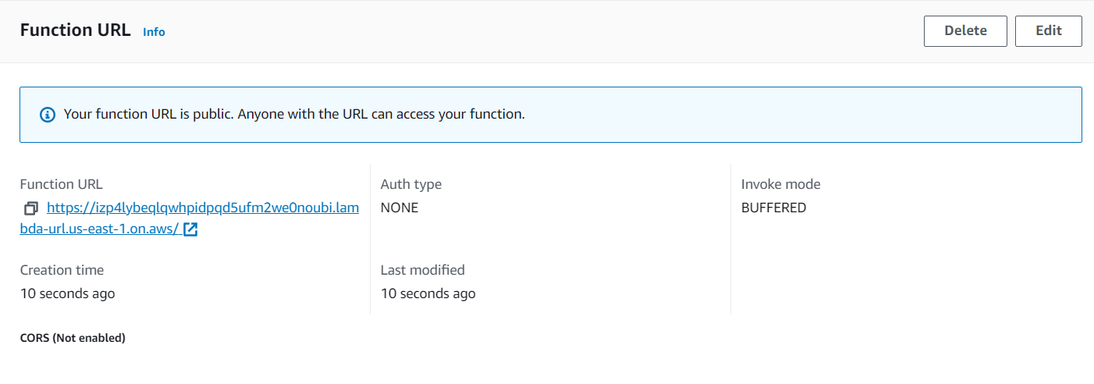

1. It opens in a browser , and shows the result of the index file in the browser

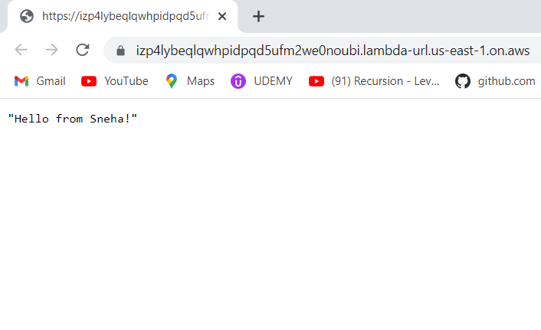

To delete the lambda function first delete the function url and then Delete the function you created.